Name: Jarosław Rybak

Class: CS 331

Project: 2

Create DB:

**CREATE TABLE VILO (**

**PLATE VARCHAR2(11),**

**STATE VARCHAR2(2),**

**LICENSE_TYPE VARCHAR2(3),**

**SUMMONS_NUMBER VARCHAR2(11),**

**ISSUE_DATE DATE,**

**VIOLAMTION_TIME DATE,**

**VIOLATION VARCHAR2(30),**

**FINE_AMOUNT FLOAT,**

**PENALTY_AMOUNT FLOAT,**

**INTEREST_AMOUNT FLOAT,**

**REDUCTION_AMOUNT FLOAT,**

**PAYMENT_AMOUNT FLOAT,**

**AMOUNT_DUE FLOAT,**

**PRECINCT VARCHAR2(3),**

**COUNTY VARCHAR2(2),**

**ISSUING_AGENCY VARCHAR2(25),**

**VIOLATION_STATUS VARCHAR2(30),**

**SUMMONS_IMAGE VARCHAR2(256));**

//Lost a lot of rows, have 412,052 through my mistake

// Insert failed for rows 35884 through 36883

// ORA-12899: value too large for column "SYS"."VILO"."ISSUING_AGENCY" (actual: 31, maximum: 25)

**ALTER TABLE vilo**

**MODIFY SUMMONS_NUMBER VARCHAR2(11) PRIMARY KEY;**

Q1:

Identify the number of violations for a 1 month period. Display 1 row

with the number of violations.

**SELECT COUNT(vilo.SUMMONS_NUMBER)**

**from vilo**

**WHERE vilo.ISSUE_DATE BETWEEN date'2021-01-01' and date'2021-01-31';**



Q2:

Identify the violations by county. Display 3 columns: county, number

of violations, total fine amount. The county with the largest number of

violations is displayed first. Display 1 row for each distinct county.

// Can't do County imported wrong.

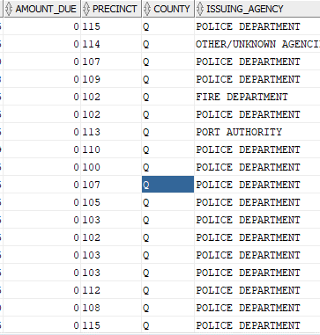

Q3:

Identify the violations by license plate. Display 4 columns: License

plate, license state, number of violations and total cost. The license

plate with the most violatios is displayed first. Display 1 row for each

distinct license plate.

**SELECT vilo.plate, vilo.STATE, COUNT(*), sum(vilo.fine_amount)**

**FROM vilo**

**GROUP BY vilo.plate, vilo.STATE, vilo.fine_amount**

**order BY COUNT(*) DESC;**

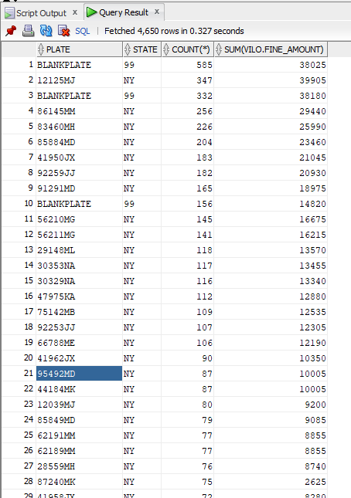

Q4:

Identify the violations by license type. Display 3 columns: license type,

number of violations and total fine amount. The license type with the

most violations is displayed first. Display 1 row for each distinct

licnese type.

**SELECT vilo.LICENSE_TYPE, COUNT(*), sum(vilo.fine_amount)**

**FROM vilo**

**GROUP BY vilo.plate, vilo.LICENSE_TYPE**

**order BY COUNT(*) DESC;**

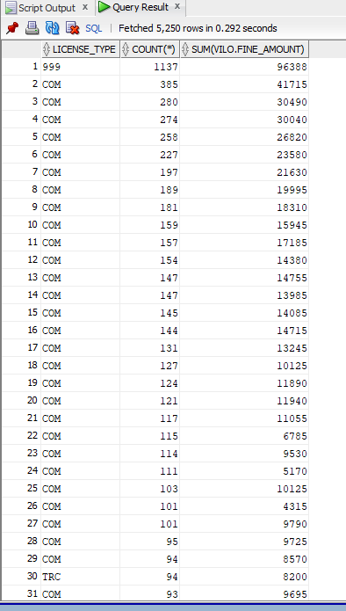

Q5:

Identify violations by license plate state. Display 3 columns: state,

number of violations and total fine amount. The state with the most

violations is displayed first. Display 1 row for each distinct state.

**SELECT vilo.state, COUNT(*), sum(vilo.fine_amount)**

**FROM vilo**

**GROUP BY vilo.plate, vilo.state, vilo.LICENSE_TYPE**

**order BY COUNT(*) DESC;**

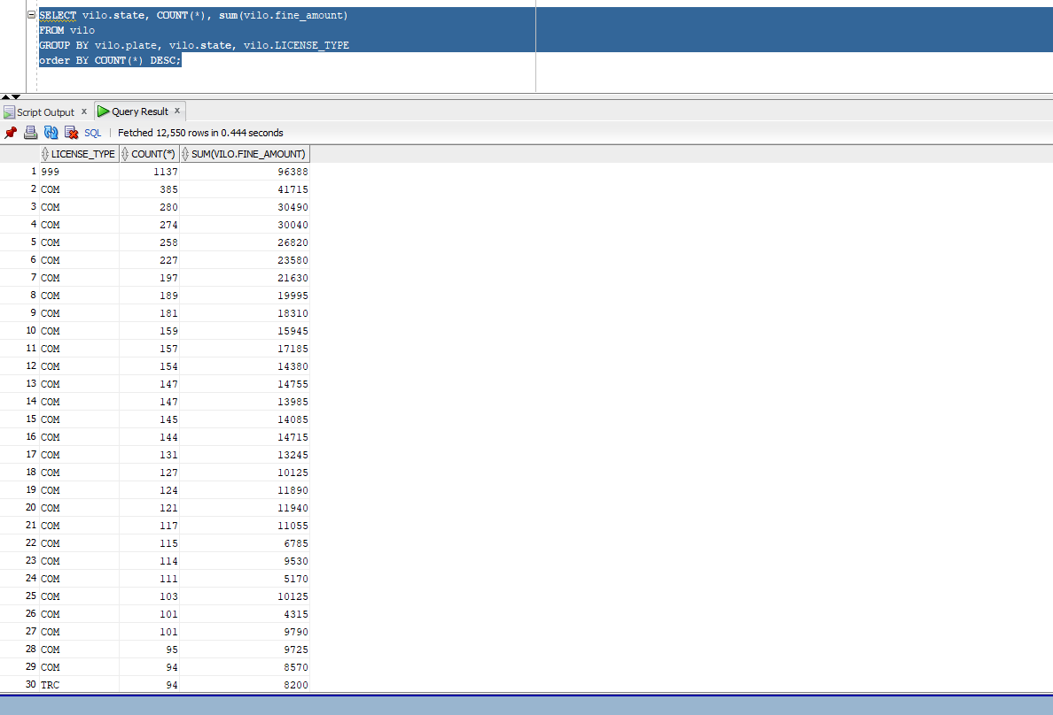

**Q6:**

Identify FIRE HYDRANT violations by month. Display 2 columns: month

and number of violations. Order by month**.**

**SELECT EXTRACT( MONTH from vilo.issue_date) AS Mon, COUNT(*)**

**from vilo**

**where vilo.violation = 'FIRE HYDRANT'**

**group by Mon**

**order by Mon ASC;**

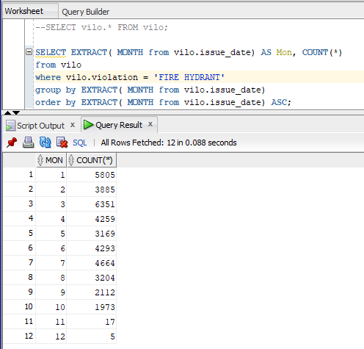

Q7:

Identify violations for the last 6 months. Dipslay 3 columns: violation,

number of violations and total cost. The most violations will be

dipslayed first. Display 1 row for each distinct violation.

**SELECT vilo.violation, COUNT(*), SUM(vilo.fine_amount)**

**from vilo**

**where vilo.issue_date >= add_months(date'2021-11-17', -6)**

**group by vilo.violation**

**ORDER BY COUNT(*) DESC;**

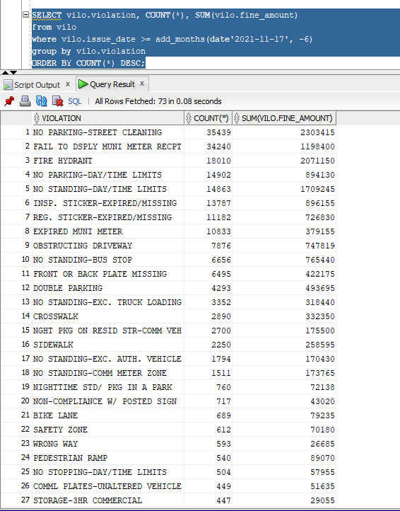

Q8:

Identify total fines for BIKE LANE. Display the total fines.

**SELECT to_char(sum(vilo.fine_amount), '$9,999,999.99' ) as Fines**

**from vilo**

**WHERE vilo.violation = 'BIKE LANE';**

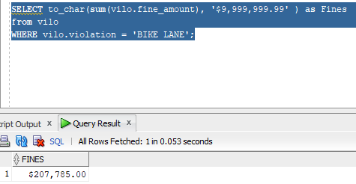

Q9:

Perform an analysis of your own choosing.

Identify violations by precinct.

Display precinct, number of violations, total fines per precinct.

Group by most violations.

**SELECT vilo.precinct, COUNT(*), to_char(sum(vilo.fine_amount), '$999,999,999.99' ) as Fines**

**from vilo**

**group by vilo.precinct**

**order by COUNT(*) DESC;**

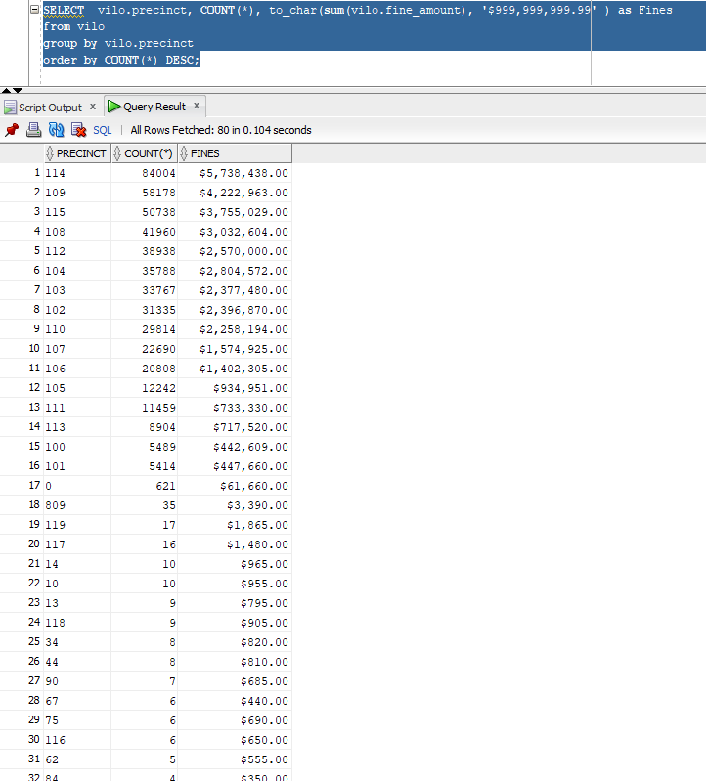

Q10:

Display the structure of ALL tables using SQL Describe.

**DESCRIBE vilo;**

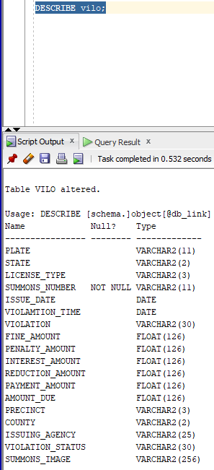

Usage: DESCRIBE [schema.]object[@db_link]

Name Null? Type

---------------- -------- -------------

PLATE VARCHAR2(11)

STATE VARCHAR2(2)

LICENSE_TYPE VARCHAR2(3)

SUMMONS_NUMBER NOT NULL VARCHAR2(11)

ISSUE_DATE DATE

VIOLAMTION_TIME DATE

VIOLATION VARCHAR2(30)

FINE_AMOUNT FLOAT(126)

PENALTY_AMOUNT FLOAT(126)

INTEREST_AMOUNT FLOAT(126)

REDUCTION_AMOUNT FLOAT(126)

PAYMENT_AMOUNT FLOAT(126)

AMOUNT_DUE FLOAT(126)

PRECINCT VARCHAR2(3)

COUNTY VARCHAR2(2)

ISSUING_AGENCY VARCHAR2(25)

VIOLATION_STATUS VARCHAR2(30)

SUMMONS_IMAGE VARCHAR2(256)

Q11:

Display the version of Oracle.

